Classification codes
Hot handle

Task code 4EC127

Description The purpose of this task is to diagnose Year 5–9 students’ misconceptions about the heating-up of different substances.

Conceptual strand / context Natural and processed materials Life and living
Energy and change Earth and beyond

Task type Objective Open ended Practical

Learning outcome focus Concept Process

Task focus level 1 2 3 4 5 6

Assessment purpose Diagnostic Formative Summative

Keywords hot, cold, conduction, temperature

Items | 1 | 2
Highest scientific literacy level
Conceptual strand / context
Domain
Response type
Assessment purpose

Task / Teacher record sheet

Student:________________________
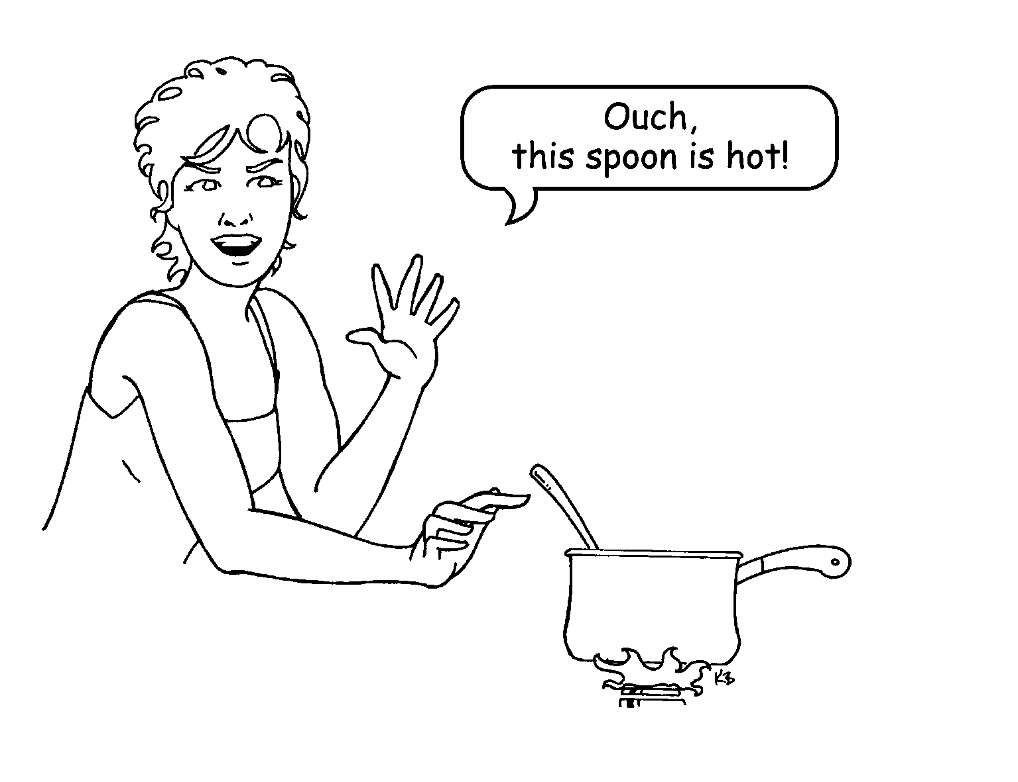
4EC127Q1
- A metal spoon, a wooden spoon and a plastic spoon are placed in a saucepan of boiling water.
If you feel the spoon handles 10 minutes later, the
A metal, plastic and wooden spoons will all be very hot.
B metal spoon will be hotter than the plastic and wooden spoons.
C plastic spoon will be hotter than the metal spoon.
D metal spoon will be colder than the wooden spoon.
4EC127Q2

- Explain the reason for your answer to Question 1.

Scientific explanation for the teacher
Solids are made of particles that vibrate about fixed positions. When they are heated the particles gain kinetic energy and vibrate more quickly. As the vibrating particles bump into each other, the energy is passed along the solid from the hot end to the cold end. Metals are better conductors of heat than wood or plastic; this is why they heat up quickly and cool down quickly. When the spoons are placed in the hot water the heat is conducted up the handles of the spoons. As the heat is conducted more quickly by metal than by wood or plastic, the metal spoon will have a hotter handle than the plastic and wooden spoons.

Student responses
Typical student responses | Explanation
The metal has an attraction for heat. | These explanations are all misconceptions based on beliefs that properties of metal enable it to hold or attract heat rather than carry heat from a hot end to a cold end.
Metal sucks up heat.
Metals hold heat better.
The metal is a better conductor than the others so the handle gets hot quickly. | This scientific explanation shows that the student has recognised that properties of metals allow them to carry heat from a hot end to a cold end more quickly than plastic or wood.

Research findings
A review of research findings (Erickson & Tiberghien, 1985) in the area of heat and temperature describes the range of ideas given by 4–13-year-olds.
In general, 8–9-year-olds describe heat as a ‘state of hotness’ along a continuum from cold through warm to hot, while 8-12-year-olds tend to associate heat with living objects, sources of heat, and the effect of heat on objects.

Conduction
Nearly all students are aware that one hot object is capable of ‘heating-up’ another cooler object when they come into direct contact, e.g. a cool saucepan gets hot when placed on a hot stove. Many students explain how metal gets hot faster than wood or plastic by stating that a metal has an attraction for heat, and a tendency to hold heat. Younger students (<13 years) tend to state that the strength of the object affects its heating and so does the strength of the heat.

The types of questions that students were asked in regard to the conduction of heat include:
- Which materials are good for the thermal insulation of a house?
- Which materials are good for the thermal insulation of a hot drink or of ice?
- Why is the handle of a metal spoon hotter than the handle of a wooden or plastic spoon when they are placed in hot water?
Common explanations given by students are listed below.
- The material retains warmth or cold, better or less well.
- The material has the property to be cold or warm because of its nature.
- The material becomes hot or cold, more or less quickly.
- The material retains, lets in or lets out hot or cold air, better or less well.
- The material takes the temperature of its surroundings.
- The material is a conductor or an insulator.

Temperature
By 8 or 9 years of age, students think that temperature is related to levels of hotness. Between ages 8 and 12 years, students are able to use and read a thermometer, but may not apply this scientifically. Some pupils think that objects of different materials in the same room are at different temperatures. They say that metal objects are colder than wood–objects.

Temperature is also often related to size. More than 50% of 12-year-olds thought that a larger ice cube would have a colder temperature than a smaller one, and hence the large ice cube takes longer to melt.

Thermal equilibrium
Students also have difficulty with the fact that everyday objects heat up. Only 30% of students, before instruction, think that the temperature of sand, sugar and water will increase when they are heated. Students have difficulty with thermal equilibrium. If several objects are in the same environment in prolonged contact, then they are at the same temperature. Even though a metal plate and a plastic plate are on the same bench most students consider that they are not at the same temperature. Similarly, different materials (flour, nails, water) placed for several hours in an oven at 60⁰C are said by the majority of students to be at different temperatures. The reasons below are typical.
- Flour is at less than 60⁰C because flour does not heat up very much.
- Nails are at more than 60⁰C because the iron heats faster.
- Water is at 60⁰C because it takes the temperature of the surroundings.
Of junior secondary students, 10% gave the correct answer before instruction and 30% gave the correct answer after instruction.

Teaching implications
Heat can be directly sensed by students, and comparisons between hot and cold can be made by touching different objects. Objects that are sensed as hot are hotter than the skin temperature, and substances sensed as cold are colder than skin temperature. Touch gives a relative measure of hotness. If you place one hand on a metal plate at room temperature and the other hand on a plastic plate at room temperature, even though both plates are at the same temperature, the metal plate feels cooler because the metal conducts heat away from the hand faster than the plastic plate. The use of thermometers is essential to overcome errors of perception about the degree of hotness. Many students will also consider heat and cold to be ‘substances’ that are in various materials rather than the thermal energy of a material.

Misconceptions about metals being strong and attracting heat or holding heat can be challenged by using lengths of wire with one end placed in hot water so that students can feel the heat moving along the wire, i.e. conduction rather than attracting or holding heat. Open discussions expose students to different explanations of these phenomena so that alternative conceptions can be challenged, and help students generalise their ideas to new examples and to appreciate their range of application.

References
Erickson, G., & Tiberghien, A. (1985). Heat and temperature. In R. Driver, E. Guesne & A. Tiberghien
(Eds), Children's Ideas in Science (pp. 52–84). Buckingham: Open University Press.

